One can add Comments to Holds to help identify what to do with the item/patron when the hold gets trapped.
Click on Place Hold, enter Patron ID and Item ID, and look further down the screen to the Hold Info section:
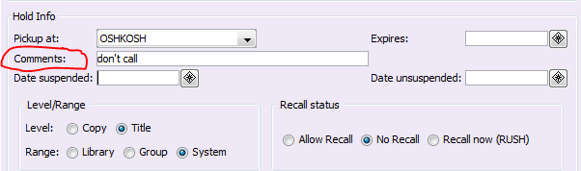
There is the Comments field. Text entered into this field appears in the pop-up Hold alert when the Item gets discharged or scanned in Check Item Status.

